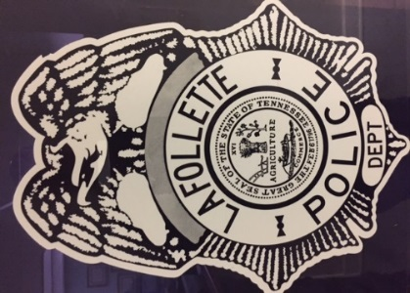

HALL OF HONOR
The City of LaFollette and the LaFollette Police Department is proud to express our appreciation and respect for those dedicated Police Officers and Dispatchers for their loyalty and long-time service by protecting and serving our community. The following have served and retired and/or passed while employed at LPD.

{We Sincerely Thank You}

Chief James Shumate End of Watch 1898
Chief Martin Fine End of Watch 1908
Chief Samuel H. Smith End of Watch 1914
Off. George Woods End of Watch 1946
Chief Lewis Perkins 1947-1953
Chief Alexander Carson 1952-1969
Chief Willie Chapman 1952-1977
Chief Howard Gaylor 1954-1974
Off. Ed Jones 1954-1976
Newman “My My” Ford No Date
Chester Bruce 1963-1974
Off. Lawrence Killion 1963-1975
Carl Coffey 1967-1981
Andrew “Honey” Starrett 1969-1977
Hugh Powers 1970-1980
Chief Boyd Carson 1971-1990
Off. Bill Woods 1972-1995
Chief Ben Baird 1973-2009
Chief Earl Carroll 1974-2003
Off. Bob Ford 1975-1985
Ronnie “Shilo” Huckaby 1975-1997
Chief Randal Jack Widener 1975-2011
Sgt. Paul Sweat 1977-1997
Off. Howard Price 1985-1998
Vickie Woodward 1985-2015
Eddie Franklin 1986-1997
Sgt. Curt Jessie 1989-1999
Det. Judge Davis 1977-1999
Det. John Chase 1986-1999
Det. Sgt. David Muse 2003-2016
Off. Odell Bailey 2004-2012
Asst. Chief Dean Woodward 1997-2003
Det. Tony Huddleston 1999-2012
David Hall 1997-2005
Brenda Moses 1976-2018

